For questions 1 and 2, find the slope of the line passing through each pair of points. If the slope is undefined, write “undefined”.
- (-8, 7) and (5, -2) | - (5, 9) and (5, -3)
- Find the value of r so that the line through (-4, 3) and (4, -3) has a slope of $\frac{2}{3}.$ | - Find the value of r so that the line through (4, 5) and (6, r) has a slope of $\frac{5}{8}.$
- In 1990, there were approximately 35,000 people in Lancaster. Five years later, the population was 38,452. Find the rate of change in the population. | - Write $y+4= -\frac{2}{3}\left(x-9\right)$ in standard form.
- If an ostrich can run 15 kilometers in 15 minutes, how many kilometers can it run in an hour? | - Write the point-slope form of an equation of the line that has slope $-\frac{3}{5}$ and passes through (2, 1)
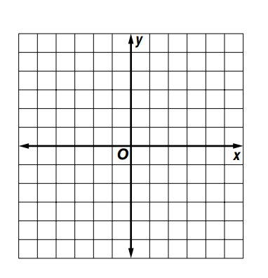  - Graph $y= -\frac{3}{4}x.$ | - Graph a line whose x-intercept is 5 and whose slope is $-\frac{3}{5}.$
- Write an equation in standard form of the line that passes through (2, -3) and (-3, 7). | - Write the point-slope form of the equation for the line that has x-intercept -3 and y-intercept -2.
For questions 13 – 20, write an equation in slope-intercept form of the line satisfying the given conditions.
- Has y-intercept -8 and slope 3 |  | - Has slope $\frac{5}{2}$ and passes through (4, -1)
- Passes through (-3, 7) and (2, 4) |  | - Is horizontal and passes through (-4, 6)
- Is parallel to the y-axis and has an x-intercept of 3 |  | - Is perpendicular to 4y = 3x – 8 and passes through (-12, 7)
- Is parallel to 3x – 5y = 7 and passes through (0, -6) |  | - Is perpendicular to the y-axis and passes through (-2, 5)
- A rental Company charges $52.99 per day, including 200 free kilometers. There is a charge of $0.12/km for additional kilometers. Write a linear equation that models this situation. |  | - Write the slope intercept form of y + 3 = -0.5(x – 10)
For questions 23 - 27, use the data in the table.
- Make a scatter plot relating the verbal scores and the math scores.  State Graduation Scores  Year Verbal Score Math Score  1970 460 488  1980 424 466  1990 410 463  2000 420 460 |  |  | 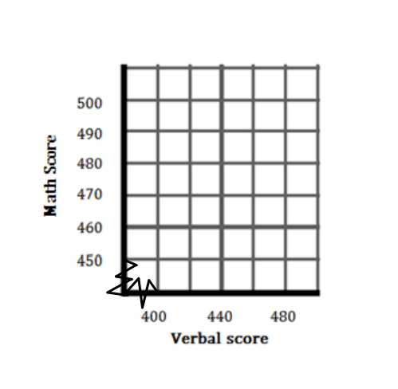  - Does the scatter plot in question 21 show a positive, a negative, or no correlation? What does that relationship represent?
- Write the equation for a line of best fit. | - Use the equation in #23 to predict the corresponding math score for a verbal score of 445.

