Chapter 4 Test Study Guide

1) Use the functions f(x) = 2x and g(x) = x² + 1 to find the value of the expression.
f(3) + g(-2)

2) Find the range of the function for the given domain.
f(x) = x³ + 1; {-2, -1, 0, 1, 2}

3) Find the range of the function for the given domain.
f(x) = x² - 2; {-4, -2, 0, 1, 3}

4) A tenth grade class is selling granola bars for a fundraiser. They earn $0.75 for every granola bar that they sell. They have ordered 300 granola bars for the sale. Write a function to determine the profit P the class earns for each bar b they sell. Find a reasonable domain and range for the function.

5) If f(x) = x² – 15 and f(a) = 49, what is the value of a? Explain.

6) If f(x) = -2x – 4 and f(m) = 10, what is the value of m? Explain.

7) List the domain and range, map the relation, and tell whether or not it is a function:
a) {(-2, 1), (3, 6), (2, -3), (4, 1)} b) {(0, 6), (1, -3), (2, 4), (0, 3)}

8) Write a rule that represents the function.
{(0,1), (1,5), (2,9), (3,13), (4,17)}

9) Write a rule that represents the function.
{(0,-1), (1,0), (2,7), (3,26), (4,63)}

10) Write a function rule that represents:
- 8 less than one third of x is y b) 6 more than the sum of a number and 4 is y

11) Tell whether or not each sequence is arithmetic. Justify your answer. If it is arithmetic, write a function rule to represent it.

- 6, 12, 18, 24, 30 b) -2, -5, -8, -11, -14 c)3, 6, 12, 24, 48

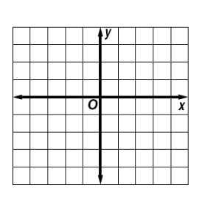
12) Graph each equation and determine whether the relationship is a function. If it is, write an equation for it.
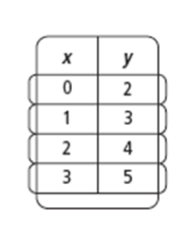
X | Y
-3 | 2
-2 | 4
-1 | 6
0 | 5
1 | 2

13) Circle the equation that best represents the function:

- (0, 4), (1, 5), (2, 12), (3, 31), (5, 129)

- y = 3x + 4
- y = 2x² + 3
- y = x³ + 4
- y = 3^{x} + 4

- (0, 0), (1, 1), (2, 3), (3, 7), (4, 15)

- y = 2x – 1
- y = x² – 1
- y = 2x² – 1
- y = 2^{x} - 1

