name ___________________ block _____ Week x Week #20M¹: 2/3 – 2/10, 2017
Solve each problem. Make sure that you show ALL WORK involved in solving the problem in order to get full credit.
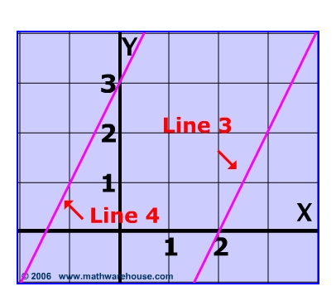  What is the equation, in slope-intercept form, for Line 3?  What is the equation, in standard form, for Line 4? | A freight elevator is being loaded with identical 76-pound boxes. The elevator can carry no more than 2000 pounds. The men loading the elevator weigh 425 pounds all together and they must ride the elevator with the boxes. How many boxes can be loaded on the elevator?  If $-3+4p= -31$, find the value of -3 p. | The amount of fertilizer needed for a lawn varies directly with the area of the lawn. If 4 pounds of fertilizer are needed for 500 square feet of lawn, write an equation relating the amount of fertilizer to the area of the lawn.  How much fertilizer is needed for Mr. Angerer’s lawn, which is rectangular in shape and measures 25 feet by 50 feet?
name ___________________ block _____ Week x Week #20M¹: 2/3 – 2/10, 2017
Solve each problem. Make sure that you show ALL WORK involved in solving the problem in order to get full credit.
What is the equation, in slope-intercept form, for Line 3?  What is the equation, in standard form, for Line 4? |  | A freight elevator is being loaded with identical 76-pound boxes. The elevator can carry no more than 2000 pounds. The men loading the elevator weigh 425 pounds all together and they must ride the elevator with the boxes. How many boxes can be loaded on the elevator?  If $-3+4p= -31$, find the value of -3p. |  | The amount of fertilizer needed for a lawn varies directly with the area of the lawn. If 4 pounds of fertilizer are needed for 500 square feet of lawn, write an equation relating the amount of fertilizer to the area of the lawn.  How much fertilizer is needed for Mr. Angerer’s lawn, which is rectangular in shape and measures 25 feet by 50 feet?
What is the equation of a line that passes through the points (0, -3) and (-4, 2)?  Point-slope ________________  Slope-Intercept _____________  Standard _________________  Given the equation:  $$\frac{x}{5}+\frac{y}{4}=-3$$  Find the slope of the line:  Find the y-intercept of the line: | Determine whether the system has one solution, infinitely many solutions, or no solution.  $$\left\{\begin{aligned}y=6x+4 \\ 6x-y= -2\end{aligned}\right.$$  A line passes through the point (2,-6) and is perpendicular to the line that has the equation x + 2y = -4. Write the equation of this line in:  Point-Slope ____________________  Slope-Intercept _________________  Standard _______________________ |  | 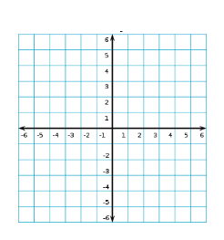  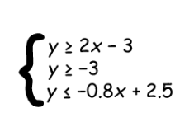  Graph the following system of inequalities:
What is the equation of a line that passes through the points (0, -3) and (-4, 2)?  Point-slope _______________  Slope-Intercept ____________  Standard _________________  Given the equation:  $$\frac{x}{5}+\frac{y}{4}=-3$$  Find the slope of the line:  Find the y-intercept of the line: | Determine whether the system has one solution, infinitely many solutions, or no solution.  $$\left\{\begin{aligned}y=6x+4 \\ 6x-y= -2\end{aligned}\right.$$  A line passes through the point (2,-6) and is perpendicular to the line that has the equation x + 2y = -4. Write the equation of this line in:  Point-Slope ____________________  Slope-Intercept _________________  Standard _______________________ |  | Graph the following system of inequalities:

