name ____________________ block _____ Week x Week #21M¹: 2/10 – 2/17, 2017
Solve each problem. Make sure that you show ALL WORK involved in solving the problem in order to get full credit.
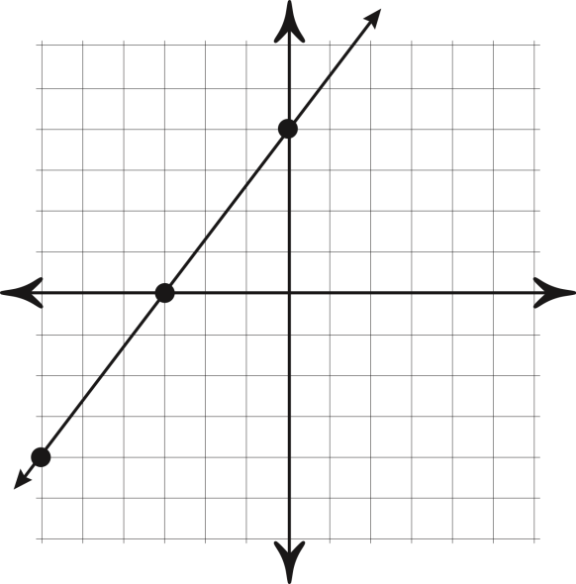  Write the equation for the line that is perpendicular to the line graphed above and goes through the point (-4, 2).  Slope-intercept ________________  Point-slope ___________________  Standard _____________________ | In a family there are two cars. In a given week, the first car gets an average of 25 miles per gallon, and the second car gets 30 miles per gallon. The two cars combined drive a total of 1600 miles in that week, for a total gas consumption of 60 gallons. How many gallons were consumed by each of the two cars that week? | If:  7(2x – 3) – 4(x + 5) = 8(x – 1) + 3  then find the value of -4x.  Flying against the jetstream, a jet travels 1980 km in 3 hours. Flying with the jetstream, the same jet travels 10080 km in 9 hours. What is the speed of the jet in still air, and what is the speed of the jetstream?

name ____________________ block _____ Week x Week #21M¹: 2/10 – 2/17, 2017
Solve each problem. Make sure that you show ALL WORK involved in solving the problem in order to get full credit.
Write the equation for the line that is perpendicular to the line graphed above and goes through the point (-4, 2).  Slope-intercept ________________  Point-slope ___________________  Standard _____________________ | In a family there are two cars. In a given week, the first car gets an average of 25 miles per gallon, and the second car gets 30 miles per gallon. The two cars combined drive a total of 1600 miles in that week, for a total gas consumption of 60 gallons. How many gallons were consumed by each of the two cars that week? | If:  7(2x – 3) – 4(x + 5) = 8(x – 1) + 3  then find the value of -4x.  Flying against the jetstream, a jet travels 1980 km in 3 hours. Flying with the jetstream, the same jet travels 10080 km in 9 hours. What is the speed of the jet in still air, and what is the speed of the jetstream?

For lunch, Kyle had a hamburger and potato chips. The hamburger had 325 calories and each chip had 12 calories. Write an equation that represents the total calories Davis consumed if he ate x potato chips.  If the meal had 541 calories, how many chips did Kyle eat?  What will be the total calories that Kyle consumes of he eats 12 potato chips? | What is the y-intercept of the line that goes through the points (-3,6) and (6,0)?  Write the equation of the line that goes through the points (-3,6) and (6,0) in standard form.  Emma drove from her home to a service station at 48 km/h. She returned home by bicycle at 16 km/h. The entire trip took 4 hours. How far was the service station from Emma’s home? | Evaluate. NO CALCULATOR!!!!!  ** $\frac{-36}{2}+ \frac{-72}{4}$  ** $\frac{-3(-7+2)}{21-6}$  ** $\left(6\right)\left(-2\right) + (-10)(-3)$  Mr. Angerer drove 211 miles in 4 hours and 15 minutes. Find his rate in miles per hour.
For lunch, Kyle had a hamburger and potato chips. The hamburger had 325 calories and each chip had 12 calories. Write an equation that represents the total calories Davis consumed if he ate x potato chips.  If the meal had 541 calories, how many chips did Kyle eat?  What will be the total calories that Kyle consumes of he eats 12 potato chips? | What is the y-intercept of the line that goes through the points (-3,6) and (6,0)?  Write the equation of the line that goes through the points (-3,6) and (6,0) in standard form.  Emma drove from her home to a service station at 48 km/h. She returned home by bicycle at 16 km/h. The entire trip took 4 hours. How far was the service station from Emma’s home? | Evaluate. NO CALCULATOR!!!!!  ** $\frac{-36}{2}+ \frac{-72}{4}$  ** $\frac{-3(-7+2)}{21-6}$  ** $\left(6\right)\left(-2\right) + (-10)(-3)$  Mr. Angerer drove 211 miles in 4 hours and 15 minutes. Find his rate in miles per hour.

