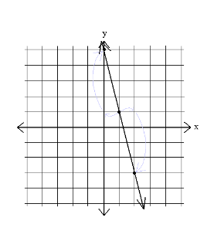
name ________________________ block _______ Week x Week #25M¹: 3/10 – 3/17, 2017
Solve each problem. Make sure that you show ALL WORK involved in solving the problem in order to get full credit.
Write the equation for the line graphed above in all three forms:  slope-intercept ______________  point-slope _________________  standard ___________________ | Emily’s parents invested $14,000 at 6% per year compounded monthly. How much money will there be in the account after 10 years?  Factor each polynomial:  8m³ + 12m² – 2m – 3  12p² + 20p – 8 | Simplify:  *(2x² + 3)(2x² – 3)  *(5x + 2)²  The total height of an office building and the granite statue that stands on top of it is 326.6 feet. The difference in heights between the building and the statue is 295.4 feet. How tall is the statue? How tall is the building?
name ________________________ block _______ Week x Week #25M¹: 3/10 – 3/17, 2017
Solve each problem. Make sure that you show ALL WORK involved in solving the problem in order to get full credit.
 | Write the equation for the line graphed above in all three forms:  slope-intercept ______________  point-slope _________________  standard ___________________ |  | Emily’s parents invested $14,000 at 6% per year compounded monthly. How much money will there be in the account after 10 years?  Factor each polynomial:  8m³ + 12m² – 2m – 3  12p² + 20p – 8 |  | Simplify:  *(2x² + 3)(2x² – 3)  *(5x + 2)²  The total height of an office building and the granite statue that stands on top of it is 326.6 feet. The difference in heights between the building and the statue is 295.4 feet. How tall is the statue? How tall is the building?
If f(x) = 2x – 3, find:  - f(-2)  - f(-1) + f(2)  If g(x) = 2x³, find:  - 3[g(t)] + 2  - g(-3) – g(1)  Write the explicit formula for the following geometric sequence:  2, 5, 12.5, 31.25, ... |  | Solve:  $$\frac{9b-3}{9}=\frac{5b+5}{3}$$  The distance a jet travels varies directly as the number of hours it flies. A jet traveled 3420 miles in 6 hours. Write a direct variation equation for the distance, d, flown in time t.  Estimate how many hours it will take for an airliner to fly 6500 miles. |  | 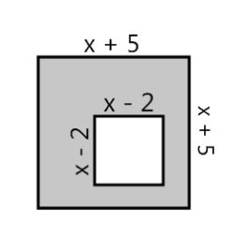  Write a simplified expression to represent the area of the shaded region.  Simplify:  $${\left(\frac{-3x^{-6}y^{-1}z^{-2}}{6x^{-2}yz^{-5}}\right)}^{-2}$$
If f(x) = 2x – 3, find:  - f(-2)  - f(-1) + f(2)  If g(x) = 2x³, find:  - 3[g(t)] + 2  - g(-3) – g(1)  Write the explicit formula for the following geometric sequence:  2, 5, 12.5, 31.25, ... |  | Solve:  $$\frac{9b-3}{9}=\frac{5b+5}{3}$$  The distance a jet travels varies directly as the number of hours it flies. A jet traveled 3420 miles in 6 hours. Write a direct variation equation for the distance, d, flown in time t.  Estimate how many hours it will take for an airliner to fly 6500 miles. |  | Write a simplified expression to represent the area of the shaded region.  Simplify:  $${\left(\frac{-3x^{-6}y^{-1}z^{-2}}{6x^{-2}yz^{-5}}\right)}^{-2}$$

