name ________________ block _____ Week x Week #26M¹: 3/17 – 3/24, 2017
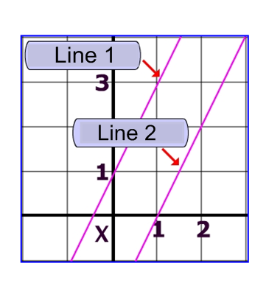
Solve each problem. Make sure that you show ALL WORK involved in solving the problem in order to get full credit.
Write the equation of Line 1 in slope-intercept form:  Write the equation of Line 2 in standard form: | The number of people who own computers has increased 23.2% annually since 1990. If half a million people owned a computer in 1990, predict how many people will own a computer in 2017.  If $-8+ \frac{x}{7}=16$, find the value of $\frac{x}{4}$. | Solve: 3x – 5y = 11  5(x + y) = 5  Simplify each expression completely:  • $15-6\left(\frac{5}{9}d-5\right)-7$  • $\frac{2}{3}np^{2}(30p^{2}+ 9n^{2}p-12)$  • ${(2m^{4}k^{3})}^{2}{(-3mk^{2})}^{3}$
name ________________ block _____ Week x Week #26M¹: 3/17 – 3/24, 2017
Solve each problem. Make sure that you show ALL WORK involved in solving the problem in order to get full credit.
Write the equation of Line 1 in slope-intercept form:  Write the equation of Line 2 in standard form: |  | The number of people who own computers has increased 23.2% annually since 1990. If half a million people owned a computer in 1990, predict how many people will own a computer in 2017.  If $-8+ \frac{x}{7}=16$, find the value of $\frac{x}{4}$. |  | Solve: 3x – 5y = 11  5(x + y) = 5  Simplify each expression completely:  • $15-6\left(\frac{5}{9}d-5\right)-7$  • $\frac{2}{3}np^{2}(30p^{2}+ 9n^{2}p-12)$  • ${(2m^{4}k^{3})}^{2}{(-3mk^{2})}^{3}$
What is the standard equation of a line that passes through the points (5, -2) and (0, -10)?  Factor each polynomial completely:  • 12x² – 11xy – y²  • 8k² + 25k + 3  • 15c³ – 65c² + 50c | Solve:  2w² + 11w = 30  A line passes through the point (2,-6) and is parallel to the line that has the equation 6x – 2y = -1. Write the equation of this line in:  Point-Slope _____________________  Slope-Intercept _________________  Standard _______________________ |  | Factor:  3x³ + 8x² – 15x – 40  12a³ – 75a  Given the equation:  $$\frac{x}{2} – \frac{y}{3} = \frac{5}{6}$$  Find the slope of the line:  Find the y-intercept of the line:
What is the standard equation of a line that passes through the points (5, -2) and (0, -10)?  Factor each polynomial completely:  • 12x² – 11xy – y²  • 8k² + 25k + 3  • 15c³ – 65c² + 50c | Solve:  2w² + 11w = 30  A line passes through the point (2,-6) and is parallel to the line that has the equation 6x – 2y = -1. Write the equation of this line in:  Point-Slope _____________________  Slope-Intercept _________________  Standard _______________________ |  | Factor:  3x³ + 8x² – 15x – 40  12a³ – 75a  Given the equation:  $$\frac{x}{2} – \frac{y}{3} = \frac{5}{6}$$  Find the slope of the line:  Find the y-intercept of the line:

