name ____________________ block _____ Week x Week #20: 2/3 – 2/10, 2017
Solve each problem. Make sure that you show ALL WORK involved in solving the problem in order to get full credit.
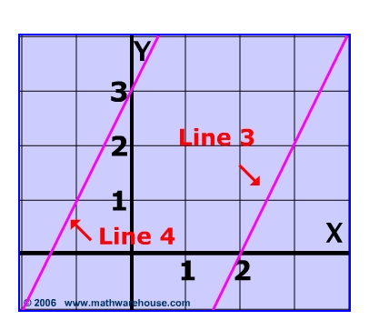  What is the equation, in slope-intercept form, for Line 3?  What is the equation, in slope-intercept form, for Line 4? | A freight elevator is being loaded with identical 76-pound boxes. The elevator can carry no more than 2000 pounds. The men loading the elevator weigh 425 pounds all together and they must ride the elevator with the boxes. How many boxes can be loaded on the elevator?  If $-3+4p= -31$, find the value of 3p. | Simplify each expression completely:  • 15 – 4(a – 5)  • -5 – 3x – x – (-16)  • 3d + 8(-d – 5)  • -20 – 2(8 – 5y) + 6y  Solve:  9(x + 3) = 4x – 3
name ____________________ block _____ Week x Week #20: 2/3 – 2/10, 2017
Solve each problem. Make sure that you show ALL WORK involved in solving the problem in order to get full credit.
What is the equation, in slope-intercept form, for Line 3?  What is the equation, in slope-intercept form, for Line 4? | A freight elevator is being loaded with identical 76-pound boxes. The elevator can carry no more than 2000 pounds. The men loading the elevator weigh 425 pounds all together and they must ride the elevator with the boxes. How many boxes can be loaded on the elevator?  If $-3+4p= -31$, find the value of 3p. |  |  | Simplify each expression completely:  • 15 – 4(a – 5)  • -5 – 3x – x – (-16)  • 3d + 8(-d – 5)  • -20 – 2(8 – 5y) + 6y  Solve:  9(x + 3) = 4x – 3
What is the slope of a line that passes through the points (0, -3) and (-4, 2)?  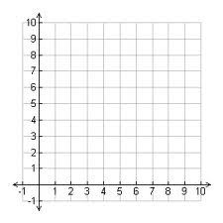  Find the length of the hypotenuse of a triangle with coordinates (6,1), (0,9), and (0,1) |  | Solve:  16 – 2(5 + 6m) = -90  A line passes through the point (2,-6) and has a slope of 2. Write the equation of the line in slope-intercept forms.  A right triangle has a hypotenuse that is 30 cm long and a leg that is 18 cm long. What is the length of the second leg? | A rectangle is 7 cm wide and 10 cm long. Find the length of a diagonal of the rectangle.  Given the equation:  4x + 3y = 8  Find the slope of the line:  Find the y-intercept of the line:
What is the slope of a line that passes through the points (0, -3) and (-4, 2)?  Find the length of the hypotenuse of a triangle with coordinates (6,1), (0,9), and (0,1) |  | Solve:  16 – 2(5 + 6m) = -90  A line passes through the point (2,-6) and has a slope of 2. Write the equation of the line in slope-intercept forms.  A right triangle has a hypotenuse that is 30 cm long and a leg that is 18 cm long. What is the length of the second leg? | A rectangle is 7 cm wide and 10 cm long. Find the length of a diagonal of the rectangle.  Given the equation:  4x + 3y = 8  Find the slope of the line:  Find the y-intercept of the line:

