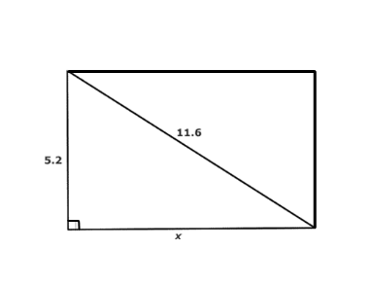
name ____________________ block _____ Week x Week #21: 2/10 – 2/17, 2017
Solve each problem. Make sure that you show ALL WORK involved in solving the problem in order to get full credit.
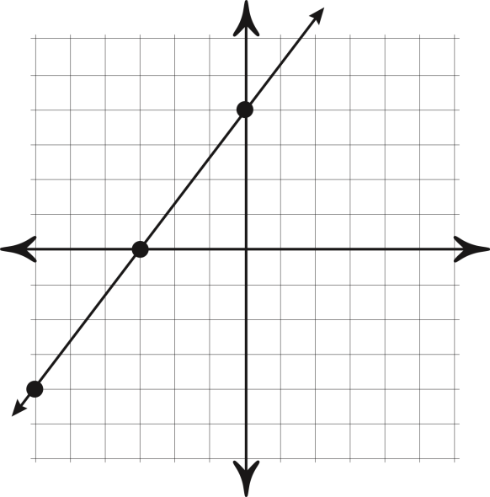  What is the slope of the line graphed above?  What is the y-intercept of the line graphed above?  Write the slope-intercept equation of the line graphed above. | Find the length of the rectangle. Round to the nearest tenth if necessary.  What is the perimeter of the rectangle?  If $0.3x+2=5$, find the value of $-6x$. | Simplify. There should be NO negative exponents!  - $\frac{m^{9}n^{3}}{m^{5}n^{6}}$  - ((7³)²)⁰  - 4⁻³  - (x³y⁶)³  - b⁴ ∙ b⁻⁶
name ____________________ block _____ Week x Week #21: 2/10 – 2/17, 2017
Solve each problem. Make sure that you show ALL WORK involved in solving the problem in order to get full credit.
What is the slope of the line graphed above?  What is the y-intercept of the line graphed above?  Write the slope-intercept equation of the line graphed above. |  | Find the length of the rectangle. Round to the nearest tenth if necessary.  What is the perimeter of the rectangle?  If $0.3x+2=5$, find the value of $-6x$. |  | Simplify. There should be NO negative exponents!  - $\frac{m^{9}n^{3}}{m^{5}n^{6}}$  - ((7³)²)⁰  - 4⁻³  - (x³y⁶)³  - b⁴ ∙ b⁻⁶
For lunch, Ray had a hamburger and potato chips. The hamburger had 325 calories and each chip had 12 calories.  Write an equation that represents the total calories Ray consumed if he ate x potato chips.  If the meal had 541 calories, how many chips did Ray eat?  What will be the total calories that Ray consumes of he eats 12 potato chips? | What is the y-intercept of the line that goes through the points (-3,6) and (6,0)?  Write the equation of the line that goes through the points (-3,6) and (6,0).  A triangle has side lengths of 12 cm, 20 cm, and 18 cm. Is this triangle a right triangle? Explain why you know this?  Put the following numbers in order from least to greatest:  $$\frac{19}{3}, \sqrt[3]{64}, \sqrt{20}, {2.5}^{2}$$ |  | Evaluate. NO CALCULATOR!!!!!  ** $\frac{-36}{2}+ \frac{-72}{4}$  ** $\frac{-3(-7+2)}{21-6}$  ** $\left(6\right)\left(-2\right) + (-10)(-3)$  Solve:  $$\frac{1}{2}m+6= -7$$
For lunch, Ray had a hamburger and potato chips. The hamburger had 325 calories and each chip had 12 calories.  Write an equation that represents the total calories Ray consumed if he ate x potato chips.  If the meal had 541 calories, how many chips did Ray eat?  What will be the total calories that Ray consumes of he eats 12 potato chips? | What is the y-intercept of the line that goes through the points (-3,6) and (6,0)?  Write the equation of the line that goes through the points (-3,6) and (6,0).  A triangle has side lengths of 12 cm, 20 cm, and 18 cm. Is this triangle a right triangle? Explain why you know this?  Put the following numbers in order from least to greatest:  $$\frac{19}{3}, \sqrt[3]{64}, \sqrt{20}, {2.5}^{2}$$ |  | Evaluate. NO CALCULATOR!!!!!  ** $\frac{-36}{2}+ \frac{-72}{4}$  ** $\frac{-3(-7+2)}{21-6}$  ** $\left(6\right)\left(-2\right) + (-10)(-3)$  Solve:  $$\frac{1}{2}m+6= -7$$

