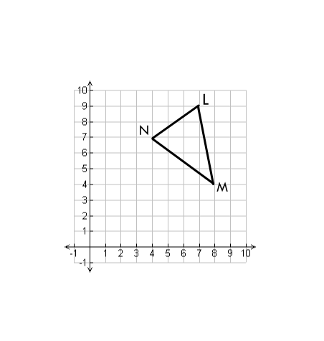
name ____________________ block _____ Week x Week #22: 2/17 – 2/24, 2017
Solve each problem. Make sure that you show ALL WORK involved in solving the problem in order to get full credit.
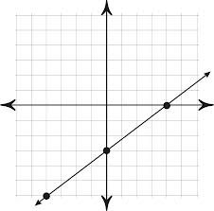  What is the y-intercept for the line graphed above?  What is the slope of the line graphed above?  Write the slope-intercept equation for the line graphed above. | ∆LMN will be translated so that the coordinates of M’ are (5, -1). What will be the coordinates of:  L’ ________________________  N’ ________________________  What was the translation rule that was used? | Solve each equation. Show all work.  12 – 9w = 75  –2(p – 5) + 7p = –5  7n – 20 = 9(4n + 1)
name ____________________ block _____ Week x Week #22: 2/17 – 2/24, 2017
Solve each problem. Make sure that you show ALL WORK involved in solving the problem in order to get full credit.
What is the y-intercept for the line graphed above?  What is the slope of the line graphed above?  Write the slope-intercept equation for the line graphed above. |  | ∆LMN will be translated so that the coordinates of M’ are (5, -1). What will be the coordinates of:  L’ ________________________  N’ ________________________  What was the translation rule that was used? |  | Solve each equation. Show all work.  12 – 9w = 75  –2(p – 5) + 7p = –5  7n – 20 = 9(4n + 1)
Simplify:  $${\left(5x^{5}\right)}^{3}$$  $$a^{4} ∙ a^{-5} ∙ a^{6}$$  $$\frac{x^{4}y^{10}}{x^{2}y}$$  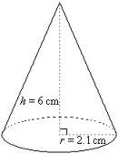  Find the volume of the cone to the nearest tenth. | 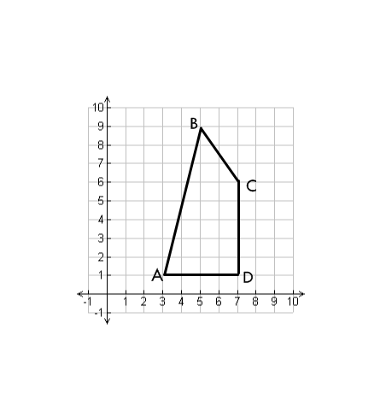  Given the equation  $$4x-3y=-36$$  Find the slope of the line.  Find the y-intercept of the line.  Evaluate. Write your answer in scientific notation.  $$\frac{1.17 × {10}^{2}}{ 5 × {10}^{-1}}$$  (2.5 x 10⁻³)(6 x 10¹⁵) |  | To the nearest tenth, what is the perimeter of quadrilateral ABCD?
Simplify:  $${\left(5x^{5}\right)}^{3}$$  $$a^{4} ∙ a^{-5} ∙ a^{6}$$  $$\frac{x^{4}y^{10}}{x^{2}y}$$  Find the volume of the cone to the nearest tenth. | Given the equation  $$4x-3y=-36$$  Find the slope of the line.  Find the y-intercept of the line.  Evaluate. Write your answer in scientific notation.  $$\frac{1.17 × {10}^{2}}{ 5 × {10}^{-1}}$$  (2.5 x 10⁻³)(6 x 10¹⁵) |  | To the nearest tenth, what is the perimeter of quadrilateral ABCD?

