name __________________________ block ____ Week x Week #24: 3/3 – 3/10, 2017
Solve each problem. Make sure that you show ALL WORK involved in solving the problem in order to get full credit.
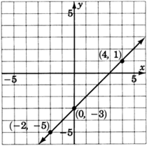  What is the slope of the line graphed above?  What is the y-intercept of the line graphed above?  Write the slope-intercept equation of the line graphed above. | 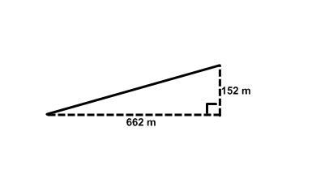  A ski lift has a horizontal length of 662 meters and a vertical height of 152 meters. Find the length of the ski lift, rounded to the nearest hundredth of a meter.  A line passes through the points (5,8) and (0, 5). Write the equation of this line in slope-intercept form. | Simplify. There should be NO negative exponents!  - $\frac{x^{4}}{x^{6}}$  - ((b²)⁴)¹⁰  - b⁻⁹ • b⁴  - (m⁶n⁻²)²  - a⁵ • a³ • a⁻²
name __________________________ block ____ Week x Week #24: 3/3 – 3/10, 2017
Solve each problem. Make sure that you show ALL WORK involved in solving the problem in order to get full credit.
What is the slope of the line graphed above?  What is the y-intercept of the line graphed above?  Write the slope-intercept equation of the line graphed above. |  | A ski lift has a horizontal length of 662 meters and a vertical height of 152 meters. Find the length of the ski lift, rounded to the nearest hundredth of a meter.  A line passes through the points (5,8) and (0, 5). Write the equation of this line in slope-intercept form. |  | Simplify. There should be NO negative exponents!  - $\frac{x^{4}}{x^{6}}$  - ((b²)⁴)¹⁰  - b⁻⁹ • b⁴  - (m⁶n⁻²)²  - a⁵ • a³ • a⁻²
At a local sports store, it costs $25.50 per day to rent camping equipment plus an additional $50 rental fee.  Write an equation relating the total cost, C, to the number of days, d, that the equipment is rented.  If the total bill comes to $203.00, for how many days did Majesty rent the camping equipment?  If Majesty rents camping equipment for 3 days, what will his total bill be? | Solve:  5(t + 7) = 2(2t + 7)  The treasure map said to start at the old oak tree, walk 50 paces south, then 35 paces west, then dig. What is the straight-line distance (in paces) from the tree to the treasure?  Points A (-4,3) and B (10,-9) are translated nine units right and three units down. What are the coordinates of these points after the translation? |  | Solve:  8k – 4 – 3k – 17 = -21  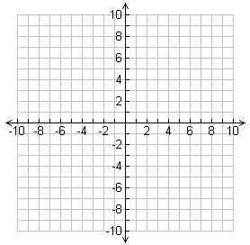  Graph the line:  $$y= \frac{2}{3}x+2$$
At a local sports store, it costs $25.50 per day to rent camping equipment plus an additional $50 rental fee.  Write an equation relating the total cost, C, to the number of days, d, that the equipment is rented.  If the total bill comes to $203.00, for how many days did Majesty rent the camping equipment?  If Majesty rents camping equipment for 3 days, what will his total bill be? | Solve:  5(t + 7) = 2(2t + 7)  The treasure map said to start at the old oak tree, walk 50 paces south, then 35 paces west, then dig. What is the straight-line distance (in paces) from the tree to the treasure?  Points A (-4,3) and B (10,-9) are translated nine units right and three units down. What are the coordinates of these points after the translation? |  | Solve:  8k – 4 – 3k – 17 = -21  Graph the line:  $$y= \frac{2}{3}x+2$$

