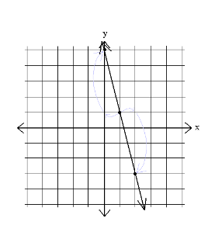
name ________________________ block _______ Week x Week #25: 3/10 – 3/17, 2017
Solve each problem. Make sure that you show ALL WORK involved in solving the problem in order to get full credit.
What is the slope of the line graphed above?  What is the y-intercept of the line  graphed above?  Write the slope-intercept equation of the line graphed above. | A jet airliner travels 3420 miles in 6 hours. What is the plane’s flying rate in miles per hour?  Write an equation to represent the total miles, d, that the plane can fly for any number of hours, t.  Estimate how many hours it will take for the airliner to fly 6500 miles.  Estimate how far the plane will fly if it is in the air for three and a half hours. | 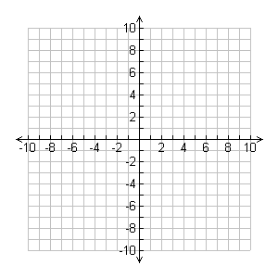  Graph the equation:  2x + y = -6  Find the slope of the line that passes through (-4,2) and (-2,10).
name ________________________ block _______ Week x Week #25: 3/10 – 3/17, 2017
Solve each problem. Make sure that you show ALL WORK involved in solving the problem in order to get full credit.
 | What is the slope of the line graphed above?  What is the y-intercept of the line graphed above?  Write the slope-intercept equation of the line graphed above. |  |  | A jet airliner travels 3420 miles in 6 hours. What is the plane’s flying rate in miles per hour?  Write an equation to represent the total miles, d, that the plane can fly for any number of hours, t.  Estimate how many hours it will take for the airliner to fly 6500 miles.  Estimate how far the plane will fly if it is in the air for three and a half hours. |  |  | Graph the equation:  2x + y = -6  Find the slope of the line that passes through (-4,2) and (-2,10).
Write each number in scientific notation:  - 12,500,000  - 0.0000000423  Determine the scale factor for the following dilation: |  |  | Solve:  $$6\left(5m-3\right)= \frac{1}{3}(24m+12)$$  Write the slope-intercept equation of a line that has a slope of 2 and a y-intercept of 4.  Write the equation of a line that passes through the points (3,1) and (2,4). |  |  | Senica is locked out of his house. The only open window is on the second floor, which is 28 feet above the ground. There is a bush along the edge of the house, so he places the neighbor’s ladder 10 feet from the house.  To the nearest foot, what length of ladder does he need to reach the window?  Simplify:  6d – 4(3d + 5) + 3(d – 10)
Write each number in scientific notation:  - 12,500,000  - 0.0000000423  Determine the scale factor for the following |  | Solve:  $$6\left(5m-3\right)= \frac{1}{3}(24m+12)$$  Write the slope-intercept equation of a line that has a slope of 2 and a y-intercept of 4.  Write the equation of a line that passes through the points (3,1) and (2,4). |  |  | Senica is locked out of his house. The only open window is on the second floor, which is 28 feet above the ground. There is a bush along the edge of the house, so he places the neighbor’s ladder 10 feet from the house.  To the nearest foot, what length of ladder does he need to reach the window?  Simplify:  6d – 4(3d + 5) + 3(d – 10)

