name __________________ block _____ Week x Week #26: 3/17 – 3/24, 2017
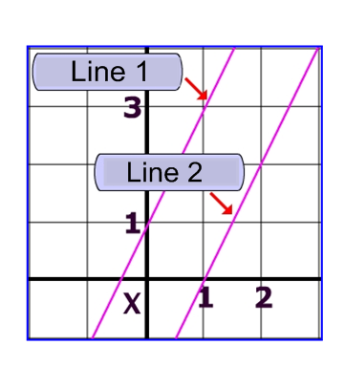
Solve each problem. Make sure that you show ALL WORK involved in solving the problem in order to get full credit.
Write the equation of Line 1 in slope-intercept form:  Write the equation of Line 2 in slope-intercept form: | Cameron bought a snowboard with a regular price of $295. It was on sale at a 25% discount. What was the sale price of the snowboard?  If $-8+ \frac{x}{7}=16$, find the value of $\frac{x}{4}$. | If there was an 8% sales tax on the sale price of Cameron’s snowboard, how much did he spend to buy the snowboard?  Simplify each expression completely:  • 15d – 6(2d – 5) – 7  • -2(4n – 1) + 15  • 9 – 4(7 – 2x)
name __________________ block _____ Week x Week #26: 3/17 – 3/24, 2017
Solve each problem. Make sure that you show ALL WORK involved in solving the problem in order to get full credit.
Write the equation of Line 1 in slope-intercept form:  Write the equation of Line 2 in slope-intercept form: |  | Cameron bought a snowboard with a regular price of $295. It was on sale at a 25% discount. What was the sale price of the snowboard?  If $-8+ \frac{x}{7}=16$, find the value of $\frac{x}{4}$. |  | If there was an 8% sales tax on the sale price of Cameron’s snowboard, how much did he spend to buy the snowboard?  Simplify each expression completely:  • 15d – 6(2d – 5) – 7  • -2(4n – 1) + 15  • 9 – 4(7 – 2x)
What is the slope of a line that passes through the points (5, -2) and (0, -10)?  Solve the following system of  equations:  $$\left\{\begin{aligned}y=8x-3 \\ y=2x+15\end{aligned}\right.$$ | Solve:  3(5 + x) + 3x = 2 – 7x  Write the equation of a line that passes through the point (2,-6) and has a slope of 3.  Simplify:  - ((n²)³)⁵  - $\frac{6^{10}}{6^{6}}$ |  | A rectangle is 9 cm wide and 14 cm long. Find the length of a diagonal of the rectangle.  Given the equation:  2x – 6y = -18  Find the slope of the line:  Find the y-intercept of the line:
What is the slope of a line that passes through the points (5, -2) and (0, -10)?  Solve the following system of  equations:  $$\left\{\begin{aligned}y=8x-3 \\ y=2x+15\end{aligned}\right.$$ | Solve:  3(5 + x) + 3x = 2 – 7x  Write the equation of a line that passes through the point (2,-6) and has a slope of 3.  Simplify:  - ((n²)³)⁵  - $\frac{6^{10}}{6^{6}}$ |  | A rectangle is 9 cm wide and 14 cm long. Find the length of a diagonal of the rectangle.  Given the equation:  2x – 6y = -18  Find the slope of the line:  Find the y-intercept of the line:

