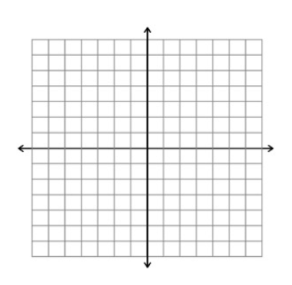
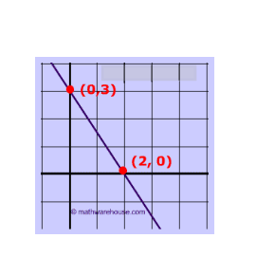
name _________________________ block _______ Week x Week #27: 3/24 – 3/30, 2017
Solve each problem. Make sure that you show ALL WORK involved in solving the problem in order to get full credit.
What is the slope of the line graphed above?  What is the y-intercept of the line  graphed above?  Write the slope-intercept equation of the line graphed above. | A hot air balloon rises 350 feet in 5 minutes. What is the balloon’s ascent rate in feet per minute?  Write an equation to represent the total feet, d, that the balloon will rise for any number of minutes, m.  How many minutes will it take for the balloon to ascend 3500 feet?  How high will the balloon ascend after 27 minutes? | Triangle ABC has vertices (4,2), (0,6), and (3,-2).  - Graph the pre-image on the coordinate plane above.  - What will the coordinates of the vertices be after the image is rotated 180º around the origin?  - Graph the image on the coordinate plane above.
name _________________________ block _______ Week x Week #27: 3/24 – 3/30, 2017
Solve each problem. Make sure that you show ALL WORK involved in solving the problem in order to get full credit.
What is the slope of the line graphed above?  What is the y-intercept of the line graphed above?  Write the slope-intercept equation of the line graphed above. | A hot air balloon rises 350 feet in 5 minutes. What is the balloon’s ascent rate in feet per minute?  Write an equation to represent the total feet, d, that the balloon will rise for any number of minutes, m.  How many minutes will it take for the balloon to ascend 3500 feet?  How high will the balloon ascend after 27 minutes? | Triangle ABC has vertices (4,2), (0,6), and (3,-2).  - Graph the pre-image on the coordinate plane above.  - What will the coordinates of the vertices be after the image is rotated 180º around the origin?  - Graph the image on the coordinate plane above.

In the table below, y is a linear function of x.  What is the slope of the line?  What is the value of y when  x = 0?  What is the equation of the line that crosses these points?  What is the value of y when x = 10?  x y  3 7  5 -3  7 -13 | Write the following linear equation in slope-intercept form:  3x – 6y = 10  NO CALCULATOR!!!!  What is the sum of all the integers between $\sqrt{20}$ and $\sqrt{82}$.  Hannah is buying a skirt that originally costs $45.50. It is on sale for 30% off the original price. What is the sale price of the skirt? | What is the distance between the points (0, 3) and (2, 0)? (Use the graph to help you find the distance!!!)  There is a 7% sales tax on the skirt that Hannah wants to buy. What will the final price of the skirt be, including tax?
In the table below, y is a linear function of x.  x y  3 7  5 -3  7 -13  What is the slope of the line?  What is the value of y when  x = 0?  What is the equation of the line that crossed these points?  What is the value of y when x = 10? | Write the following linear equation in slope-intercept form:  3x – 6y = 10  NO CALCULATOR!!!!  What is the sum of all the integers between $\sqrt{20}$ and $\sqrt{82}$.  Hannah is buying a skirt that originally costs $45.50. It is on sale for 30% off the original price. What is the sale price of the skirt? | What is the distance between the points (0, 3) and (2, 0)? (Use the graph to help you find the distance!!!)  There is a 7% sales tax on the skirt that Hannah wants to buy. What will the final price of the skirt be, including tax?

